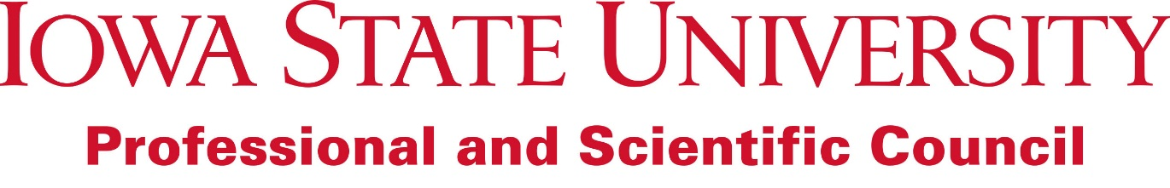
The Iowa State University (ISU) Professional and Scientific Council (Council) continually strives towards service, advocacy, and representation of the Professional and Scientific Employees of ISU. As part of this service, advocacy, and representation, the Council—in communication with all Professional and Scientific Employees of ISU—has identified a number of strategic initiatives important to Professional and Scientific employees, and the greater ISU community. These initiatives were initially identified during the July 2016 Council meeting, and have been evaluated and summarized by Clayton Johnson (Professional and Scientific Council President) and the Professional and Scientific Council Executive Committee. These initiatives are organized by their connection to the purpose of the Professional and Scientific Council, as identified in the Constitution of the Professional and Scientific Council (items in bold below). This is not meant to be a finite list, and initiatives will evolve over time. If you have any questions regarding any of the initiatives below or have suggestions for additional initiatives, please send them to the Professional and Scientific Council Executive Committee (pands-exec@iastate.edu).
The Iowa State University Professional and Scientific Council serves as a resource and an advocate for Professional and Scientific employees.
Mentoring: Build upon the momentum from previous years in relation to voicing the need for developing new, and improving existing mentoring programs available to P&S employees.
Health and Wellness: Collaborate with the ISU Wellbeing office within University Human Resources to promote and expand current wellness efforts around campus. Including—but not limited to—affordable fitness center memberships.
Professional Development: Continue to explore, research, recommend, and implement new and innovative professional development opportunities, including (but not limited to) the continuation and expansion of the current Professional and Scientific Council Professional Development Conference.
Supervisory Training: Identify opportunities to promote the need for the training of supervisors of Professional and Scientific employees and recommend/develop additional resources.
The Iowa State University Professional and Scientific Council identifies the needs of its constituents.
Parking and Travel: Explore, expand, and promote efforts to alleviate campus congestion, including (but not limited to) exploring affordable CyRide passes for P&S employees, RideShare options, and improving commuting capability for cyclists.
Annual Evaluations: Advocate for the need of required annual evaluations, and tools to help improve consistency of evaluations across the university. Collaborate with University Human Resources to do so.
The Iowa State University Professional and Scientific Council provides information and advice in response to the needs of its constituents.
Council Communications: Continue to open the lines of communication between Professional and Scientific councilors and their constituents. Work towards effective, efficient, and informative communication to meet the needs of Professional and Scientific employees.
Affordable Child Care: Continue to advocate for these needs with University Human Resources, identify resources available to P&S employees within the community.
Continue to work with Human Resources regarding Human Capital Capability. Specifically, encourage communication by and amongst Human Resource Liaisons across campus to strive for transparency and consistency.
The Iowa State University Professional and Scientific Council recommends policies and procedures to the administration that benefit Professional and Scientific employees and assists in fulfilling the mission of Iowa State University.
Family leave policies: Research regarding current family leave policies (including maternity leave), identifying gaps in this policy (including paternity leave and time allocation for adoption), and identify areas where the policy could be expanded (including care of family members).
Timekeeping (in relation to FLSA guidelines): Serve as a voice and an advocate for affected P&S employees as the new Timekeeping policy is developed. Within this scope, also include concerns regarding flexible work environments (including how work-from-home arrangements would/could fit within these new policies).
Compensatory Time: Work with Human Resources to explore options regarding the development of a Compensatory Time policy, and how this would work in relation to the FLSA guidelines and upcoming Classification and Compensation review.
Career Development and Compensation: Work with Human Resources to develop tools to create a fairer and more equitable compensation policies. Continue the effort to encourage and provide avenues for career development and the identification of career ladders.
Employment Appointments: Continue to work with ISU administration to help better define the appropriate use of term or continuous appointments. Work to recommend a policy regarding definitions and usage of term appointment, if needed.

