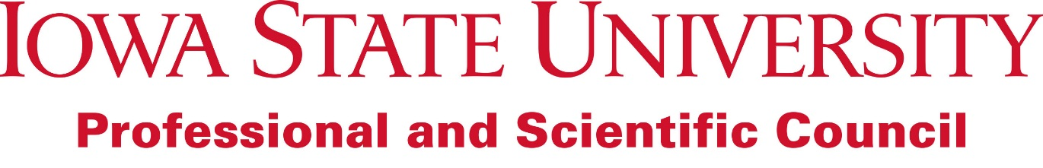

Council Motion: Inclusion of statement regarding Diversity and Inclusion in the FY 2017 Priorities and Strategic Initiatives Document

Submitted by: Executive Committee
December 1, 2016

Whereas: The Executive Committee has created a statement regarding Diversity and Inclusion to be included in the FY 2017 Priorities and Strategic Initiatives Document

Whereas: Diversity and Inclusion are important priorities for the university, and have been identified as such in the FY 2017-FY 2022 University Strategic Plan

It is moved: That the following statement be inserted in the Professional and Scientific Council FY 2017 Priorities and Strategic Initiative Document under the priority “The Iowa State University Professional and Scientific Council serves as a resource and an advocate for Professional and Scientific employees”:

Diversity and Inclusion: The Professional and Scientific Council will serve as an advocate for diversity and inclusion at Iowa State University. Council will work to identify available resources and create new opportunities for advocacy, education, and professional development for Professional and Scientific employees on topics which relate to diversity and inclusion. Council will also advocate for, and collaborate with, employees, students, and visitors to ensure that Iowa State University is a safe, welcoming, and inclusive place to work and to learn.

