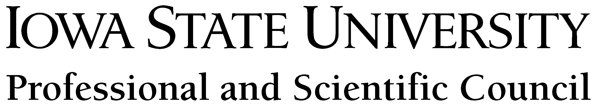

Outstanding New Professional and Scientific Council Member CYtation Award

Iowa State University thrives because talented employees here work to make a real commitment to excellence. This award recognizes Professional and Scientific Council members, particularly those who are new to council and are committed to making a difference.

For this reason, the Professional and Scientific Council calls for nominations for the "Outstanding New Professional and Scientific Council Member CYtation Award."

Outstanding New Professional and Scientific Council Member CYtation Award Criteria: As of the nomination deadline (December 1), the individual must be a Professional and Scientific Council member newly elected or newly appointed within 18 months of the beginning of his/her first term. In addition, the individual must meet the following criteria:
- Has established a pattern of reliability and responsibility while making a notable difference
- Fosters cooperation and has strong interpersonal relationships with fellow Professional and Scientific Council members
- Exhibits potential for future contributions to Iowa State University

What happens if a candidate is selected to receive the Outstanding New Professional and Scientific Council Member CYtation Award?
The nominator and awardee will be notified of the award prior to the Professional and Scientific Council Awards Ceremony. The Iowa State University president, or designee, will present the awardee with a certificate of recognition at the Professional and Scientific Council Awards Ceremony, which takes place annually (typically February or March). The awardee also will receive a $50 gift certificate to the ISU Bookstore. Additional announcements may appear in Inside Iowa State, the Professional and Scientific Council newsletter, or other Iowa State publications. Nominations for the award will be received annually.

Who can make nominations for the Outstanding New Professional and Scientific Council Member CYtation Award? Any Iowa State University employee can submit an award nomination for any Professional and Scientific Council member eligible for the award.

Due Date for the Outstanding New Professional and Scientific Council Member CYtation Award: December 1

Submit nomination form electronically to: P&S Awards Committee: pands-a@iastate.edu. Please submit phonetic spelling of the nominator and nominee with the form. In the case the nominee receives the award, coordinators of the Professional and Scientific Council Awards Ceremony must prepare correct pronunciation of nominator and awardee names.

Questions: Please submit any questions regarding the Outstanding New Professional and Scientific Council Member CYtation Award to: pands-a@iastate.edu

Award Information and Nomination Forms are available online:
http://www.pscouncil.iastate.edu/activities/awards/homepage.html

Nomination Form for the Outstanding New Professional and Scientific Council Member CYtation Award

Name of Nominator _______________________________________

Submitted By (Department/College/Unit) _______________________________________

Contact Name of Person Submitting _______________________________________

Telephone Number for Nominator _______________________________________

E-mail Address for Nominator _______________________________________

Name of Nominee for the Outstanding New Professional and Scientific Council Member CYtation Award

_______________________________________

P&S Position/Department/P-Level _______________________________________

Telephone Number for Nominee _______________________________________

E-mail Address for Nominee _______________________________________

Office Address for Nominee _______________________________________

Outstanding New Professional and Scientific Council Member CYtation Award: Please address way(s) the individual has established a pattern of reliability and responsibility while making a notable difference, fosters cooperation and has strong interpersonal relationships with fellow Professional and Scientific Council members, and exhibits potential for future contributions to Iowa State University. Please submit phonetic spelling of the nominator and nominee with the form. In the case the nominee receives the award, coordinators of the Professional and Scientific Council Awards Ceremony must prepare correct pronunciation of nominator and awardee names.

Note: Please limit the nomination to 750 words.

